**Load balancer:**

1. **Launch 2-instances.&Host a website on each .**

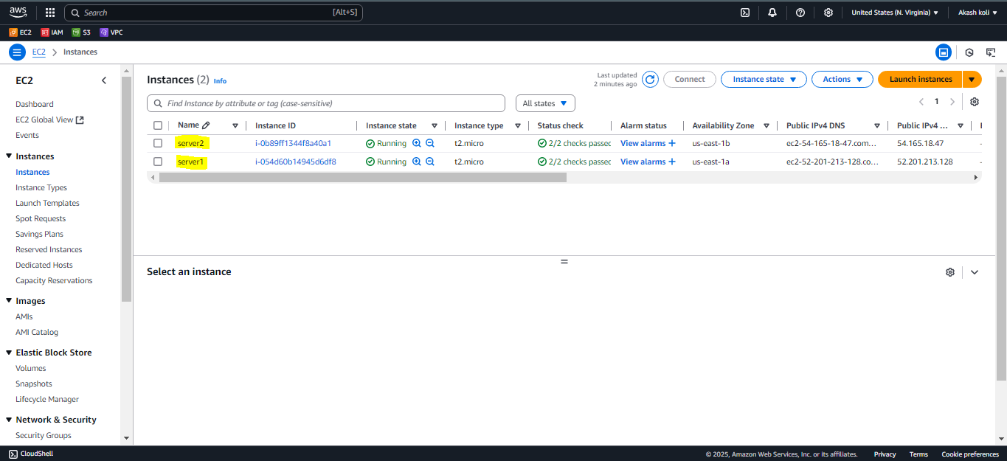

**Server1:**



**Server2:**



**2. Create Load balancer:**

1. create security group-**allow http-80**
2. **Create Target group and register targets:**

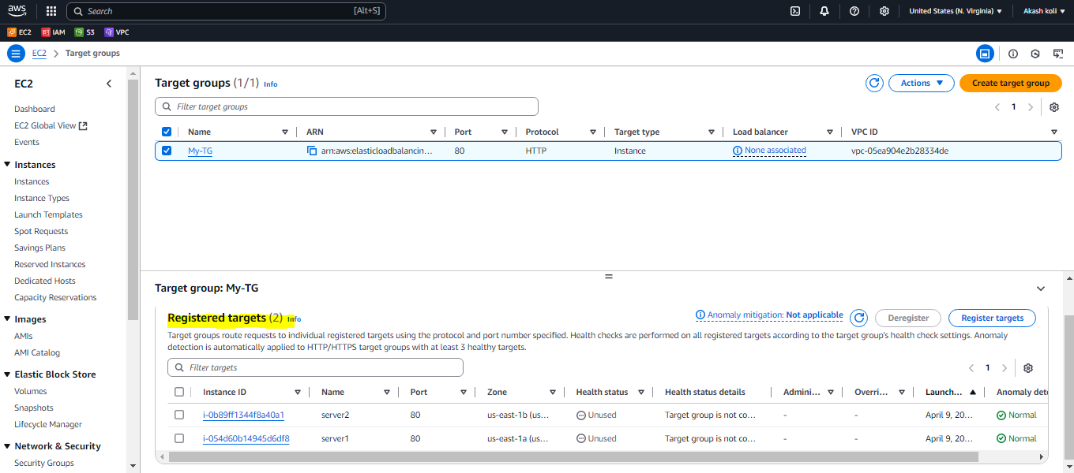

**LB:**

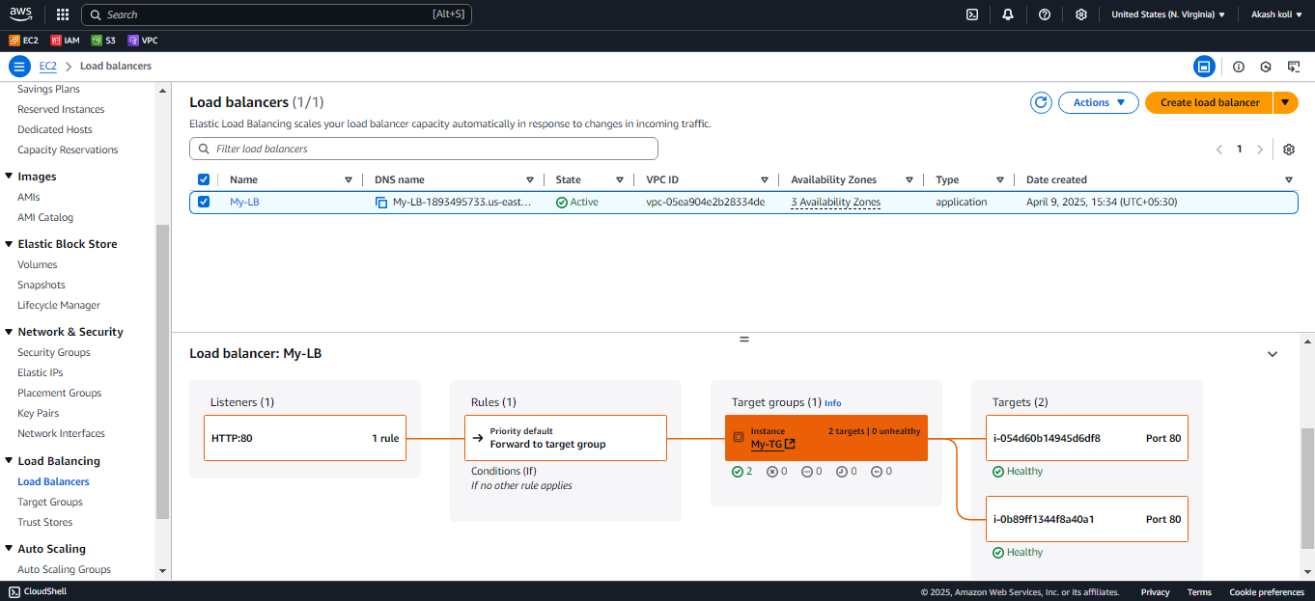

**Out;-**

1. **Check load balancer DNS : able to route traffic to both instance while refreshing page.**

